**Heart Disease Analysis Report**

**1. Introduction**

Heart disease remains a leading cause of mortality worldwide, making it essential to analyze factors contributing to its prevalence. This report explores patterns, correlations, and risk factors associated with heart disease based on a dataset containing multiple health-related attributes.

**2. Dataset Overview**

The dataset consists of various features such as BMI, smoking habits, alcohol consumption, history of stroke, physical and mental health, general health, and chronic conditions. The dataset includes **319,794** records and **18 features**.

**3. Key Insights**

**3.1 Gender and Heart Disease**

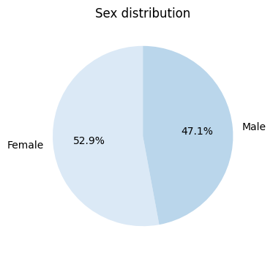

* **Insight:** Males have a higher probability of developing heart disease compared to females.
* **Possible Explanation:** This may be due to differences in lifestyle, genetic factors, and higher rates of risk-taking behaviors among men.

**3.2 Smoking and Heart Disease**

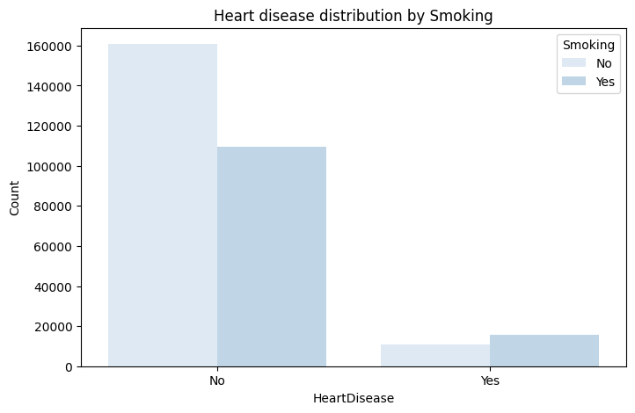

* **Insight:** Smokers have a higher probability of developing heart disease.
* **Possible Explanation:** Smoking damages blood vessels, increases blood pressure, and contributes to plaque buildup in arteries, leading to cardiovascular issues.

**3.3 Alcohol Consumption and Heart Disease**

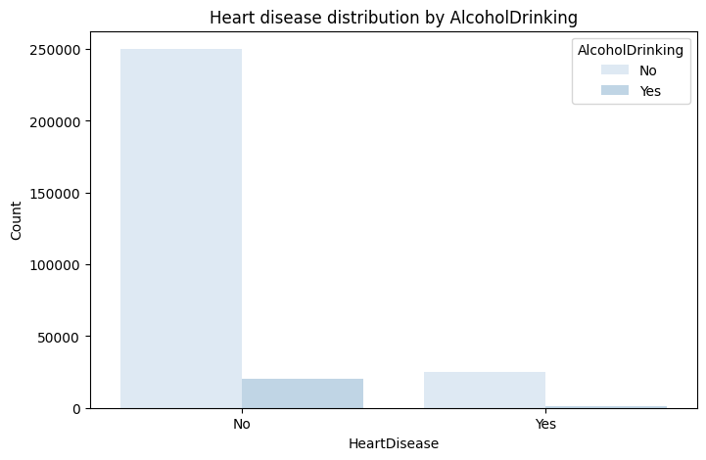

* **Insight:** Alcohol consumption does not show a significant impact on heart disease.
* **Possible Explanation:** While excessive alcohol consumption is linked to heart disease, moderate drinking may not have a direct correlation.

**3.4 Stroke and Heart Disease**

* **Insight:** History of strokes does not show a significant impact on heart disease in this dataset.
* **Possible Explanation:** Although stroke and heart disease share common risk factors, stroke alone may not be a strong predictor of heart disease.

**3.5 Age and Heart Disease**

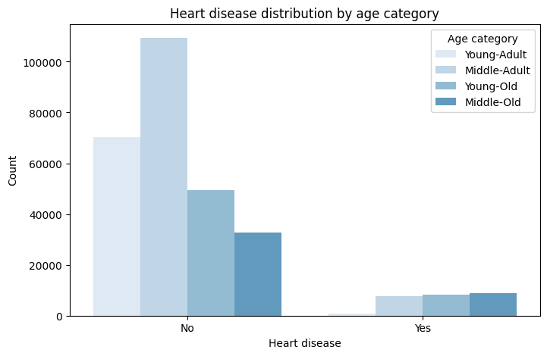

* **Insight:** Older individuals have a higher probability of developing heart disease.
* **Possible Explanation:** Aging leads to the natural wear and tear of the cardiovascular system, increasing susceptibility to heart disease.

**3.6 Diabetes and Heart Disease**

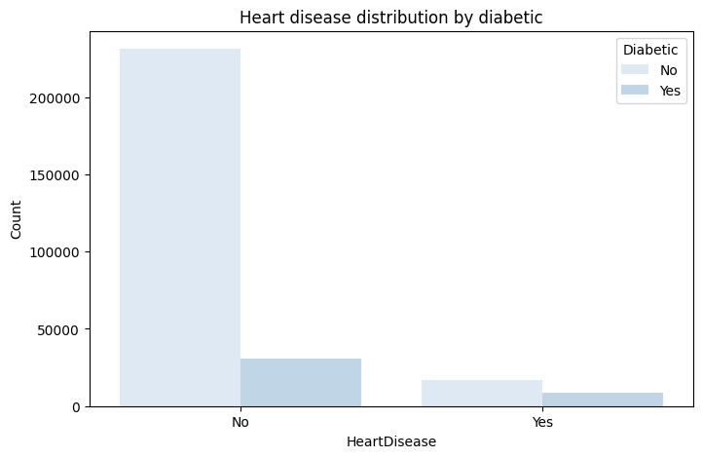

* **Insight:** Diabetes does not show a significant impact on heart disease in this dataset.
* **Possible Explanation:** While diabetes is a known risk factor, the dataset may not capture the severity and duration of diabetes cases, leading to a weaker correlation.

**3.7 General Health and Heart Disease**

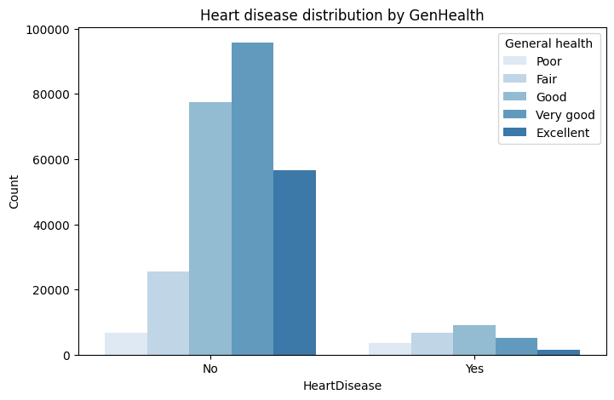

* **Insight:** Individuals with lower general health have a higher probability of developing heart disease.
* **Possible Explanation:** Poor overall health often reflects an accumulation of risk factors such as poor diet, lack of exercise, and other underlying conditions.

**3.8 Asthma and Heart Disease**

* **Insight:** Asthma does not show a significant impact on heart disease.
* **Possible Explanation:** While respiratory conditions may strain the heart over time, asthma alone may not be a direct contributor to heart disease.

**3.9 Kidney Disease and Heart Disease**

* **Insight:** Kidney disease does not show a significant impact on heart disease in this dataset.
* **Possible Explanation:** While kidney disease is linked to cardiovascular problems, the dataset may not sufficiently highlight its role in heart disease development.

**3.10 Skin Cancer and Heart Disease**

* **Insight:** Skin cancer does not show a significant impact on heart disease.
* **Possible Explanation:** Skin cancer is primarily linked to sun exposure rather than cardiovascular health.

**3.11 Sleep Quality and Heart Disease**

* **Insight:** People with good sleep quality are less likely to develop heart disease.
* **Possible Explanation:** Proper sleep is essential for heart health, regulating blood pressure, reducing stress, and supporting overall cardiovascular function.

**4. Conclusion and Recommendations**

**4.1 Conclusion**

The analysis of this dataset highlights key factors influencing heart disease risk. While **smoking, gender, age, and general health** show strong correlations with heart disease, factors like **alcohol consumption, stroke history, diabetes, asthma, kidney disease, and skin cancer** show little to no significant impact.

**4.2 Recommendations**

1. **Encourage smoking cessation programs** to reduce heart disease risk.
2. **Promote regular health checkups for older adults** to detect early signs of cardiovascular issues.
3. **Improve public awareness on the importance of general health** in preventing heart disease.
4. **Encourage proper sleep habits** as a preventive measure against heart disease.
5. **Further studies should explore underlying factors** related to diabetes and kidney disease to assess their long-term impact on heart health.